Seabrook Middle School Principal Communication
October 2023
October was a busy month filled with many activities, events, and teacher professional development. Students traveled near- the marsh and far- Salem, Massachusetts and had some meaningful learning experiences while also having some fun.
Professional Development
We started the month off with staff professional development focusing on refining intervention groups and using NWEA scores to set goals for our students. Each teacher this month was asked to meet 1:1 with their class to set ELA and Math goals for the winter tests. The NWEA data is important in helping us determine skills needed to be taught so that all students will successful on our state assessment in the spring. Staff are attending Math, Science and ELA Professional Development in November, in addition to visiting schools to deepen peer collaboration in these content areas.
Student Learning Experiences
Our 5th graders are in year three of the Eel Project with the team from UNH Cooperative Extension and the NH Sea Grant. Students have the unique opportunity to explore the local salt marsh with their teachers and "real" scientists. They observe the marsh, collect salinity data, and study the tides. This hands -on project is also multi-disciplinary and helps students understand the importance of the salt marsh historically, scientifically and culturally.
A huge thank you to our community partners and the 5th grade team for providing this unique educational experience for our students. UNH will be back in the spring to go deeper with the learning experience- maybe the students will even see an eel!
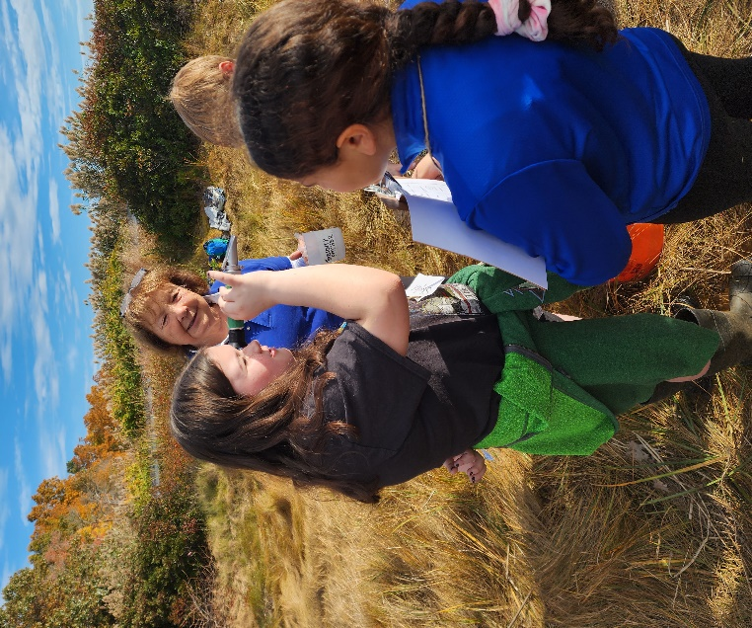
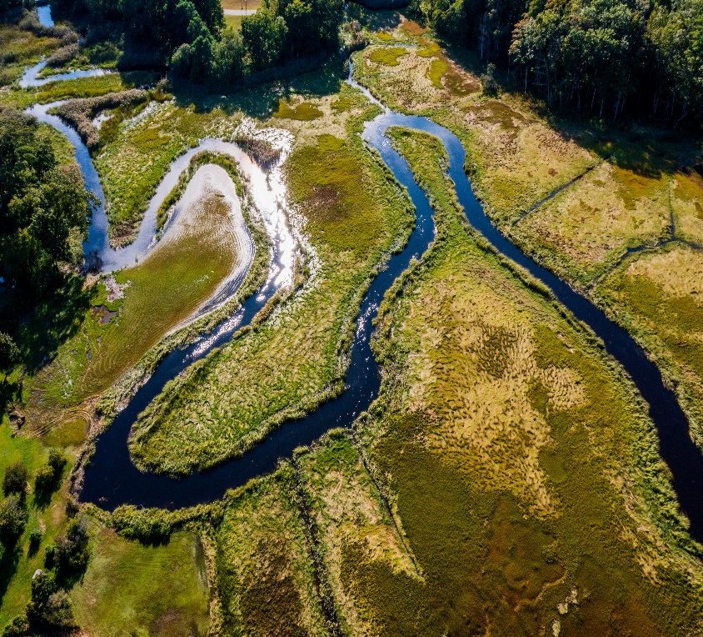

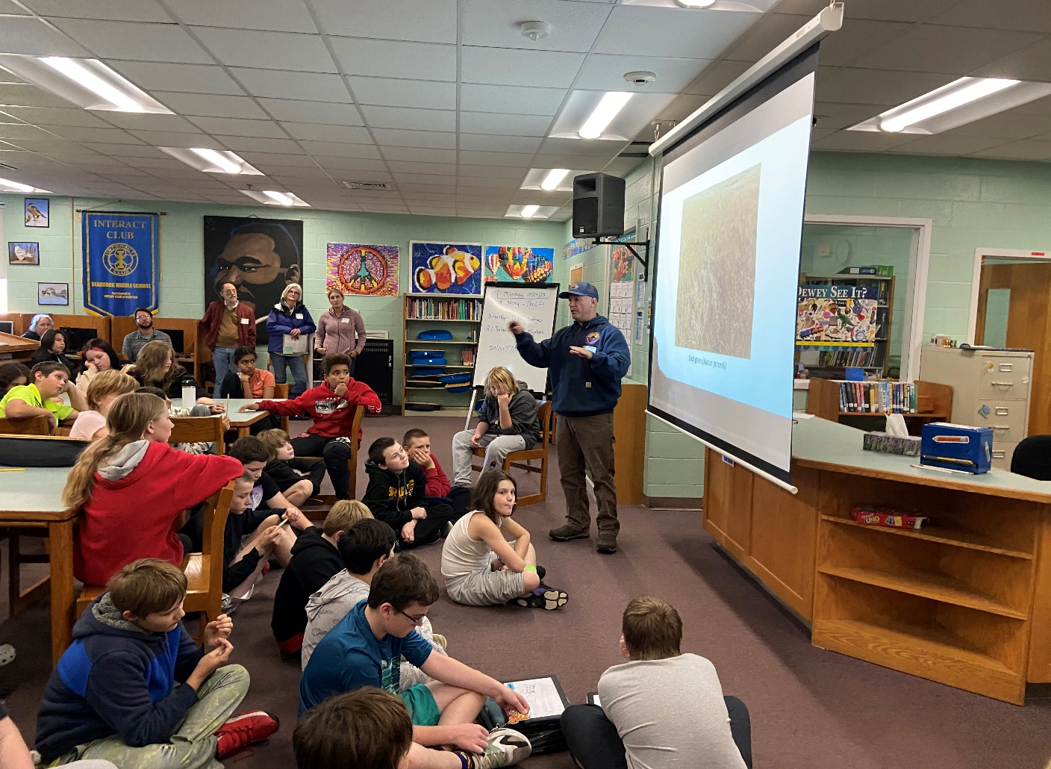
Grade 6 classes were invited to participate in a “Great Marsh Discovery Day” which took place right here in the wetlands in our backyard. This opportunity is provided by the Seabrook Hampton Estuary Alliance (SHEA) and a local Wetlands Biologist. This science class was a wonderful follow up with our Ecology School experience as students continue to learn more about ecosystems and Aquatic Biomes.

Grade 7 traveled to Salem, Massachusetts on Halloween, it was an experience our students won’t soon forget. Thousands of people in costumes filled the city, which has so much rich history. Students visited the Witch Museum, Witch Dungeon and recognized many of the historical figures they had read about in A Break with Charity.
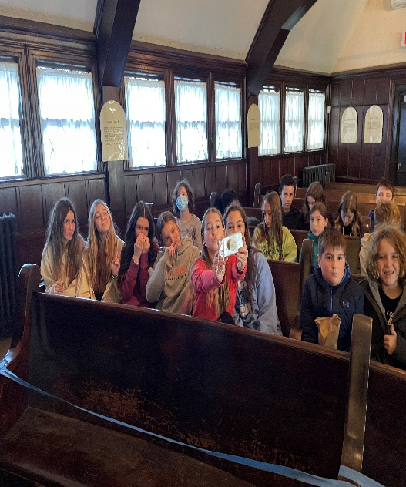
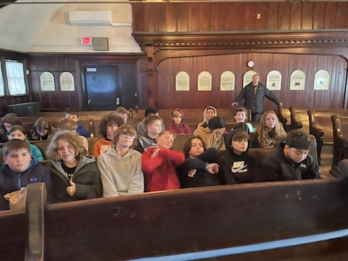

Grade 8 began the Mission Kid to Kid program with 18 students 18 from Winnacunnet High School mentoring our grade 8 students. This program was created by a high school student who wanted to support Grade 8 students transition to high school. We are so thankful for these students who mentor twice a month.
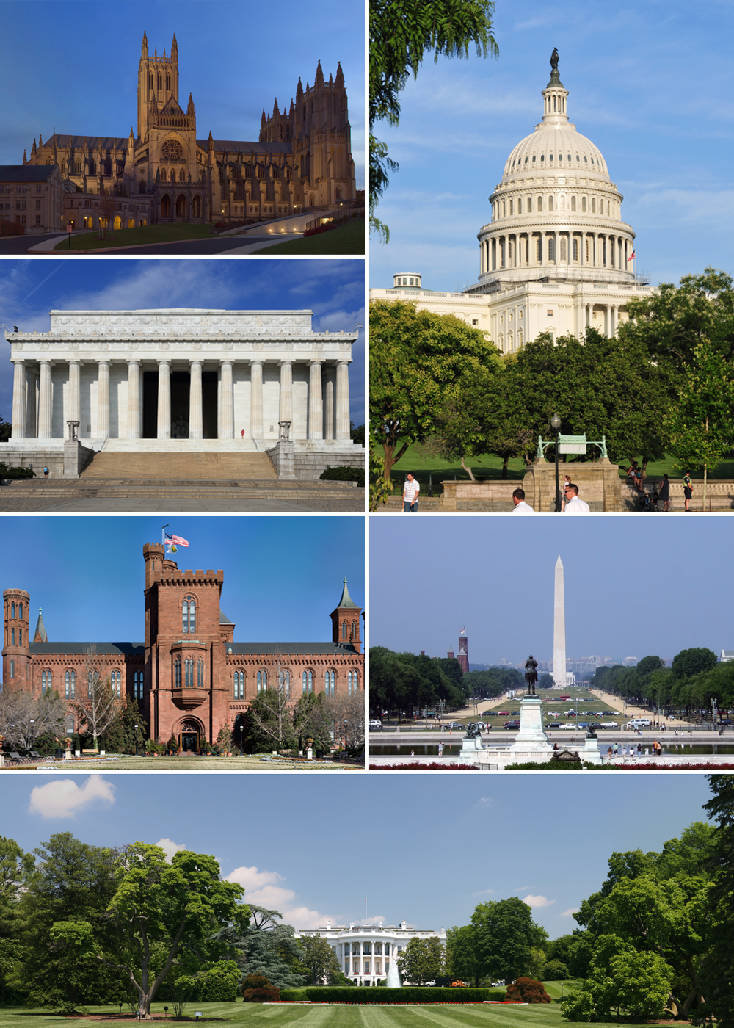Washington, D.C here we come!

Thank you, School Board Members, for approving our Grade 8 Washington, D.C. class trip. We had our first parent meeting and we will be selling Holiday Wreaths as the first fundraiser, it would look beautiful on your front door. More details next month about other opportunities to support this class.

After School Support
We have 4 teachers who are providing after school Math support. They will meet with students on Tuesdays and Thursdays 2:45-3:30- late bus will be provided. We mailed home letters to 37 families. This program starts November 28th.
More good news to share in December, stay tuned.

